

SQL Assignment

Jake Shiel



July 20, 2024

JustIT

[Company address]

Contents

MySQL Part 1: 4

1. 4

a. Using the Query 2 change the points to reads times by 10 and plus 100. 4

b. Change the Query 2 code to create a discount factor so the table now shows a discount header and changing the (point + 10) *100 4

2. Write a SQL query that selects name, unit price, and new column called new price which is based on this expression, (unit price * 1.1 ). 4

3. In this task create a new query to find all the customers with a birth date of > '1990-01-01' 5

4. 5

a. Select sql_inventory. 5

b. Write a query to find out the name of the product with most amount in stock. 5

5. Write a query to find out the name of the most expensive product. 5

6. 5

a. Select sql_store. 5

b. Write a query to find out the first name, last name, address and the birthdate of the oldest customer. 5

Creating an EER Diagram Assignment 1 6

My SQL Part 2(Presentation): 7

1. Using count, get the number of cities in the USA 7

2. Find out what the population and average life expectancy for people in Argentina (ARG) is. 7

3. Using ORDER BY, LIMIT, what country has the highest life expectancy?# 7

4. Select 25 cities around the world that start with the letter 'F' in a single SQL query. 7

5. Create a SQL statement to display columns Id, Name, Population from the city table and limit results to first 10 rows only. 8

6. Create a SQL statement to find only those cities from city table whose population is larger than 2000000. 8

7. Create a SQL statement to find all city names from city table whose name begins with “Be” prefix. 8

8. Create a SQL statement to find only those cities from city table whose population is between 500000-1000000. 8

9. Create a SQL statement to find a city with the lowest population in the city table. 8

10. (BONUS 1) Create a SQL statement to find the capital of Spain (ESP). 9

11. (BONUS 2) Create a SQL statement to list all the languages spoken in the Caribbean region. 9

12. (BONUS 3) Create a SQL statement to find all cities from the Europe continent. 9

Creating an EER Diagram Assignment 2 10

1. Identify the primary key in country table. 10

2. Identify the primary key in city table. 10

3. Identify the primary key in countrylanguage table. 10

4. Identify the foreign key in city table. 10

5. Identify the foreign key in countrylanguage table. 10

My SQL Part 2(Learner Sheet): 11

1. Count Cities in USA 11

2. Country with Highest Life Expectancy 11

3. "New Year Promotion: Featuring Cities with 'New : 11

4. Display Columns with Limit (First 10 Rows): 12

5. Cities with Population Larger than 2,000,000: 12

6. Cities Beginning with 'Be' Prefix: 12

7. Cities with Population Between 500,000-1,000,000 12

8. Display Cities Sorted by Name in Ascending Order: 13

9. Most Populated City: 13

11. City with the Lowest Population: 13

12. Country with Largest Population: 14

13. Capital of Spain: 14

14. Country with Highest Life Expectancy 14

15. Cities in Europe: 14

16. Average Population by Country: 15

17. Capital Cities Population Comparison: 15

18. Countries with Low Population Density: 15

19. Cities with High GDP per Capita 16

20. Display Columns with Limit (Rows 31-40): 16

Task 3 – Interview Part 1: 17

1. What is a Query? 17

2. What is the SELECT statement? 17

3. What is the WHERE clause? 17

4. What is the Primary Key? 17

5. What is a Database? 18

Task 4 – Interview questions Part 2: 18

1. List the different types of relationships in SQL and give examples. 18

2. What is Normalization? 18

3. Modify query to show the population of Germany. 18

4. Select the query which gives the name of countries beginning with U. 18

5. Select the answer which shows the problem with this SQL code - the intended result should be the continent of France: 19

6. Select the code which shows the countries that end in A or L. 19

7. Given the table on the left, select the query which produces this table below. 19

# MySQL Part 1:

## 

## Using the Query 2 change the points to reads times by 10 and plus 100.

SELECT last_name, first_name, points, (points * 10) + 100  
FROM CUSTOMERS;

## Change the Query 2 code to create a discount factor so the table now shows a discount header and changing the (point + 10) *100

SELECT last_name, first_name, points, (points+10) * 100 AS discount_factor  
FROM CUSTOMERS;

## Write a SQL query that selects name, unit price, and new column called new price which is based on this expression, (unit price * 1.1 ).

SELECT name, unit_price,(unit_price*1.1) AS new_price  
FROM PRODUCTS;  
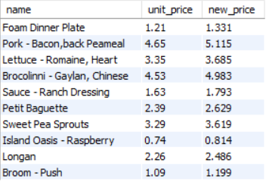

## In this task create a new query to find all the customers with a birth date of > '1990-01-01'

SELECT first_name, birth_date  
FROM CUSTOMERS  
WHERE birth_date > ‘1990-01-01’;

## 

## Select sql_inventory.

USE sql_inventory;

## Write a query to find out the name of the product with most amount in stock.

SELECT name, quantity_in_stock  
FROM products  
ORDER BY quantity_in_stock DESC  
LIMIT 1;



## Write a query to find out the name of the most expensive product.

SELECT name, unit_price  
FROM products  
ORDER BY unit_price DESC  
LIMIT 1;



## 

## Select sql_store.

USE sql_store;

## Write a query to find out the first name, last name, address and the birthdate of the oldest customer.

SELECT first_name, last_name, address, birth_date  
FROM CUSTOMERS  
ORDER BY birth_date ASC  
LIMIT 1;



# Creating an EER Diagram Assignment 1

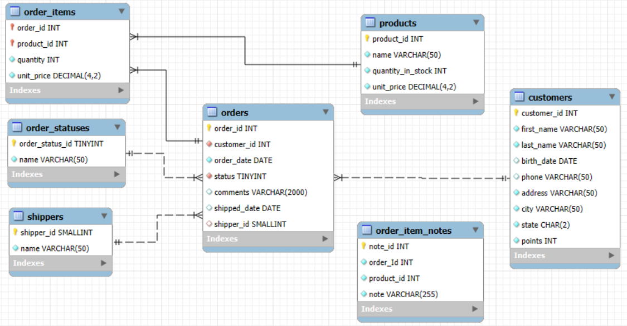

Rather than writing a few sentences I summarised the relationships in a table as seen below

|  |  |  |  |  |
| --- | --- | --- | --- | --- |
| Table 1 – Primary Key | Table 2 – Foreign Key | Cardinality | Identifying/ Nonidentifying | Common Field |
| order_items | products | 1 - many | Identifying | product_id |
| order_items | orders | 1 - many | Identifying | order_id |
| orders | order_statuses | 1 - many | Non-Identifying | order_status_id |
| orders | shippers | 1 - many | Non-Identifying | shipper_id |
| orders | customers | 1 - many | Non- Identifying | customer_id |

# My SQL Part 2(Presentation):

There are some questions that are the same between the ‘MySQL Assignment Part 2.pptx’ and the ‘Learner Answer Sheet’. I will first answer the PowerPoint questions and then the word doc. Also I have saved separate scripts for each

## Using count, get the number of cities in the USA

SELECT COUNT(ID) AS US_cities  
FROM city  
WHERE CountryCode = 'USA';



## Find out what the population and average life expectancy for people in Argentina (ARG) is.

SELECT Name, Population, LifeExpectancy  
FROM country  
WHERE Code = 'ARG';



## Using ORDER BY, LIMIT, what country has the highest life expectancy?#

SELECT Name, LifeExpectancy  
FROM country  
ORDER BY LifeExpectancy DESC  
LIMIT 1;  


## Select 25 cities around the world that start with the letter 'F' in a single SQL query.

SELECT Name  
FROM city  
WHERE Name LIKE 'F%'  
LIMIT 25;

## Create a SQL statement to display columns Id, Name, Population from the city table and limit results to first 10 rows only.

SELECT ID, Name, Population  
FROM city  
LIMIT 10;

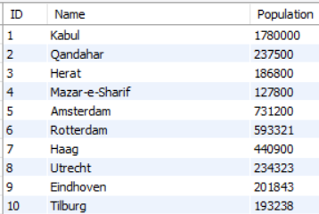

## Create a SQL statement to find only those cities from city table whose population is larger than 2000000.

SELECT Name, Population  
FROM city  
WHERE Population > 2000000;

Answer: 92 Cities

## Create a SQL statement to find all city names from city table whose name begins with “Be” prefix.

SELECT Name  
FROM city  
WHERE Name LIKE 'Be%';

Answer: 51 Cities

## Create a SQL statement to find only those cities from city table whose population is between 500000-1000000.

SELECT Name, Population  
FROM city  
WHERE Population BETWEEN 500000 AND 1000000;

Answer: 303 Cities

## Create a SQL statement to find a city with the lowest population in the city table.

SELECT Name, Population  
FROM city  
ORDER BY Population ASC  
LIMIT 1;



## (BONUS 1) Create a SQL statement to find the capital of Spain (ESP).

SELECT ID, city.Name, Capital  
FROM city  
JOIN country  
ON city.CountryCode = country.code  
WHERE CountryCode = 'ESP' AND city.ID = country.Capital;

## (BONUS 2) Create a SQL statement to list all the languages spoken in the Caribbean region.

SELECT DISTINCT Language, Region  
FROM country  
JOIN countrylanguage  
ON country.Code = countrylanguage.CountryCode  
WHERE Region = 'Caribbean';

## (BONUS 3) Create a SQL statement to find all cities from the Europe continent.

SELECT city.Name, Continent  
FROM city  
JOIN country  
ON city.CountryCode = country.code  
WHERE Continent = 'Europe';

Answer: 841 Cities

# Creating an EER Diagram Assignment 2

## Identify the primary key in country table.

Code

## Identify the primary key in city table.

ID

## Identify the primary key in countrylanguage table.

CountryCode + Language

## Identify the foreign key in city table.

CountryCode

## Identify the foreign key in countrylanguage table.

CountryCode

# My SQL Part 2(Learner Sheet):

1. Count Cities in USA**:** *Scenario:* You've been tasked with conducting a demographic analysis of cities in the United States. Your first step is to determine the total number of cities within the country to provide a baseline for further analysis.

SELECT COUNT(ID) AS US_cities

FROM city

WHERE CountryCode = 'USA';

1. Country with Highest Life Expectancy**:** *Scenario:* As part of a global health initiative, you've been assigned to identify the country with the highest life expectancy. This information will be crucial for prioritizing healthcare resources and interventions.

SELECT Name, LifeExpectancy

FROM country

ORDER BY LifeExpectancy DESC

LIMIT 1;



1. "New Year Promotion: Featuring Cities with 'New : *Scenario:* In anticipation of the upcoming New Year, your travel agency is gearing up for a special promotion featuring cities with names including the word 'New'. You're tasked with swiftly compiling a list of all cities from around the world. This curated selection will be essential in creating promotional materials and enticing travellers with exciting destinations to kick off the New Year in style.

SELECT Name

FROM city

WHERE Name LIKE 'new%';  
I did 2 queries on to search for ‘new’ anywhere in the city name: 14 cities  
The other query only when it started with the word ‘new’: 12 cities

1. A screenshot of a computer

   Description automatically generatedDisplay Columns with Limit (First 10 Rows): *Scenario:* You're tasked with providing a brief overview of the most populous cities in the world. To keep the report concise, you're instructed to list only the first 10 cities by population from the database.

SELECT Name, Population

FROM city

ORDER BY Population DESC

LIMIT 10;

1. A screenshot of a computer

   Description automatically generatedCities with Population Larger than 2,000,000: *Scenario:* A real estate developer is interested in cities with substantial population sizes for potential investment opportunities. You're tasked with identifying cities from the database with populations exceeding 2 million to focus their research efforts.

SELECT Name, Population

FROM city

WHERE Population > 2000000;

Answer: 92 Cities

1. A screenshot of a computer

   Description automatically generatedCities Beginning with 'Be' Prefix: *Scenario:* A travel blogger is planning a series of articles featuring cities with unique names. You're tasked with compiling a list of cities from the database that start with the prefix 'Be' to assist in the blogger's content creation process.

SELECT Name

FROM city

WHERE Name LIKE 'Be%';

Answer: 51 Cities

1. Cities with Population Between 500,000-1,000,000**:** *Scenario:* An urban planning committee needs to identify mid-sized cities suitable for infrastructure development projects. You're tasked with identifying cities with populations ranging between 500,000 and 1 million to inform their decision-making process.

SELECT Name, Population

FROM city

WHERE Population BETWEEN 500000 AND 1000000;

Answer: 303 Cities

1. A screenshot of a computer

   Description automatically generatedDisplay Cities Sorted by Name in Ascending Order: *Scenario:* A geography teacher is preparing a lesson on alphabetical order using city names. You're tasked with providing a sorted list of cities from the database in ascending order by name to support the lesson plan.

SELECT ID, Name, Population

FROM city

ORDER BY Name ASC;

1. Most Populated City: *Scenario:* A real estate investment firm is interested in cities with significant population densities for potential development projects. You're tasked with identifying the most populated city from the database to guide their investment decisions and strategic planning.

SELECT Name, Population

FROM city

ORDER BY Population DESC

LIMIT 1;

1. A screenshot of a computer

   Description automatically generated City Name Frequency Analysis: Supporting Geography Education*Scenario*: In a geography class, students are learning about the distribution of city names around the world. The teacher, in preparation for a lesson on city name frequencies, wants to provide students with a list of unique city names sorted alphabetically, along with their respective counts of occurrences in the database. You're tasked with this sorted list to support the geography teacher's l

SELECT DISTINCT Name, COUNT(ID)

FROM city

GROUP BY Name

ORDER By Name ASC;

1. City with the Lowest Population: *Scenario:* A census bureau is conducting an analysis of urban population distribution. You're tasked with identifying the city with the lowest population from the database to provide a comprehensive overview of demographic trends.

SELECT Name, Population

FROM city

ORDER BY Population ASC

LIMIT 1;

1. Country with Largest Population: *Scenario:* A global economic research institute requires data on countries with the largest populations for a comprehensive analysis. You're tasked with identifying the country with the highest population from the database to provide valuable insights into demographic trends.

SELECT Name, Population

FROM country

ORDER BY Population DESC

LIMIT 1;

1. Capital of Spain: *Scenario:* A travel agency is organizing tours across Europe and needs accurate information on capital cities. You're tasked with identifying the capital of Spain from the database to ensure itinerary accuracy and provide travelers with essential destination information.

SELECT ID, city.Name, Capital

FROM city

JOIN country

ON city.CountryCode = country.code

WHERE CountryCode = 'ESP' AND city.ID = country.Capital;

1. Country with Highest Life Expectancy**:** *Scenario:* A healthcare foundation is conducting research on global health indicators. You're tasked with identifying the country with the highest life expectancy from the database to inform their efforts in improving healthcare systems and policies.

SELECT Name, LifeExpectancy

FROM country

ORDER BY LifeExpectancy DESC

LIMIT 1;

1. Cities in Europe: *Scenario:* A European cultural exchange program is seeking to connect students with cities across the continent. You're tasked with compiling a list of cities located in Europe from the database to facilitate program planning and student engagement.

SELECT city.Name, Continent

FROM city

JOIN country

ON city.CountryCode = country.code

WHERE Continent = 'Europe';

Answer: 841 Cities

1. A screenshot of a computer

   Description automatically generatedAverage Population by Country: *Scenario:* A demographic research team is conducting a comparative analysis of population distributions across countries. You're tasked with calculating the average population for each country from the database to provide valuable insights into global population trends.

SELECT CountryCode, AVG(Population)

FROM city

GROUP BY CountryCode;  
Answer: 232 Cities

1. A screenshot of a computer

   Description automatically generatedCapital Cities Population Comparison: *Scenario:* A statistical analysis firm is examining population distributions between capital cities worldwide. You're tasked with comparing the populations of capital cities from different countries to identify trends and patterns in urban demographics.

SELECT city.Name, city.Population

FROM country

JOIN city

ON country.Capital = city.ID;

1. A screenshot of a computer

   Description automatically generatedCountries with Low Population Density: *Scenario:* An agricultural research institute is studying countries with low population densities for potential agricultural development projects. You're tasked with identifying countries with sparse populations from the database to support the institute's research efforts.

SELECT Name, Population/SurfaceArea As Pop_Density

FROM country

ORDER BY Pop_Density ASC

LIMIT 20;

BONUS TASKS: Challenge yourself: These are optional tasks. Feel free to skip.

1. Cities with High GDP per Capita**:** *Scenario:* An economic consulting firm is analyzing cities with high GDP per capita for investment opportunities. You're tasked with identifying cities with above-average GDP per capita from the database to assist the firm in identifying potential investment destinations.

SELECT AVG(GNP/city.population) AS AVG_GNP_per_capita  
FROM country  
JOIN city  
ON country.Capital = city.ID;

-- AVG GNP per capita = '0.1833658394' --

SELECT city.Name AS City, GNP/city.population AS GNP_per_capita  
FROM country  
JOIN city  
ON country.Capital = city.ID  
WHERE GNP/city.population > 0.1833658394;

Answer: 36 Cities

1. A screenshot of a computer

   Description automatically generatedDisplay Columns with Limit (Rows 31-40): *Scenario:* A market research firm requires detailed information on cities beyond the top rankings for a comprehensive analysis. You're tasked with providing data on cities ranked between 31st and 40th by population to ensure a thorough understanding of urban demographics.

SELECT Name, Population  
FROM country   
ORDER BY Population DESC  
LIMIT 10 OFFSET 30;

# Task 3 – Interview Part 1:

## What is a Query?

A query is a request for data or information from a database. It allows you to retrieve, insert, update, or delete data. Queries are written using SQL (Structured Query Language)

## What is the SELECT statement?

The SELECT statement is used to select data from a database. The data returned is stored in a result table, called the result-set.

SELECT *column1*,*column2, ...*  
FROM *table_name*;

Here, column1, column2, ... are the field names of the table you want to select data from. If you want to select all the fields available in the table, use the following syntax:

SELECT  *  FROM *table_name*;

## What is the WHERE clause?

The WHERE clause is used to filter records. It is used to extract only those records that fulfil a specified condition.

SELECT *column1*,*column2, ...*  
FROM *table_name*  
WHERE *condition*;

Example: Select all customers from Mexico. SQL requires single quotes around text values. However, numeric fields should not be enclosed in quotes

|  |  |
| --- | --- |
| SELECT * FROM Customers WHERE Country='Mexico'; | SELECT * FROM Customers WHERE CustomerID = 1; |

The specified condition is a combination of one or more expressions using the logical operator. The following operators can be used in the WHERE clause:

|  |  |  |  |
| --- | --- | --- | --- |
| Operator | Description | Operator | Description |
| = | Equal | <> | Not equal |
| > | Greater than | BETWEEN | Between a range |
| < | Less than | LIKE | Search for a pattern |
| >= | Greater than or equal | IN | Specify multiple possible values for a column |
| <= | Less than or equal |

## What is the Primary Key?

A primary key is a unique identifier for each record in a database table. It ensures that each record can be uniquely identified and it cannot be NULL. A primary key can consist of one or multiple columns.

## What is a Database?

A database(DB) is an organised collection of data, typically stored in electronic format. It allows you to input data, organise the data and retrieve the data quickly. Traditional databases are organised by fields, records and files.

# Task 4 – Interview questions Part 2:

## List the different types of relationships in SQL and give examples.

A one-to-one relationship occurs when a single record in a table is related to only one record in another table, and vice versa.

Example: Consider a database of a small company where each employee has a unique employee ID and a corresponding parking spot number. Here, one employee is related to one parking spot, and one parking spot is related to one employee.

A one-to-many relationship occurs when a single record in one table can be related to one or more records in another table. Conversely, many-to-one describes the same relationship from the opposite direction.

Example: In a library database, one author can write multiple books, but each book has a single author. Here, one author relates to many books (one-to-many), and each book relates to one author (many-to-one).

A many-to-many relationship occurs when multiple records in one table are related to multiple records in another table.

Example: In a school database, a student can enroll in many courses, and each course can have many students enrolled in it. This requires a third table (often called a junction or join table), such as Enrolments, which contains records linking students to courses

## What is Normalization?

Normalization is the process of organizing data in a database to reduce redundancy and improve data integrity. The goal is to divide large tables into smaller and more manageable pieces while creating relationships between them. This process usually involves several stages, called normal forms

## Modify query to show the population of Germany.

SELECT population   
FROM world  
WHERE name = 'Germany';

## Select the query which gives the name of countries beginning with U.

SELECT name   
FROM world   
WHERE name LIKE 'U%';

## Select the answer which shows the problem with this SQL code - the intended result should be the continent of France:

SELECT continent FROM world WHERE 'name' = 'France'

b) 'name' should be name

## Select the code which shows the countries that end in A or L.

SELECT name F  
ROM world   
WHERE name LIKE '%a' OR name LIKE '%l' ;

## Given the table on the left, select the query which produces this table below.

SELECT name, population   
FROM world   
WHERE population BETWEEN 1000000 AND 1250000;